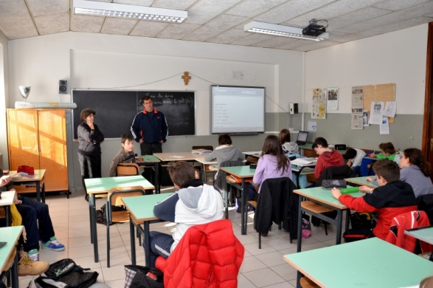

Bianca’s father came in class to help us learn Hungarian …

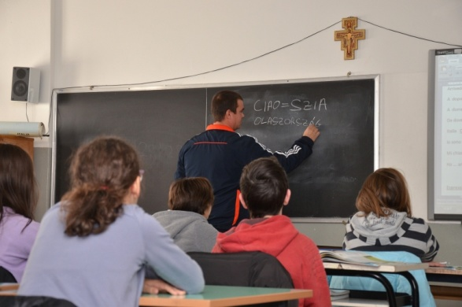

What a difficult language!

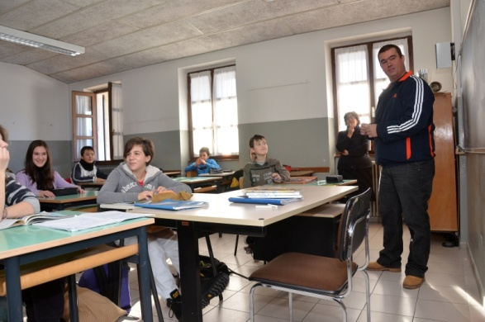

But that’s also fun:…

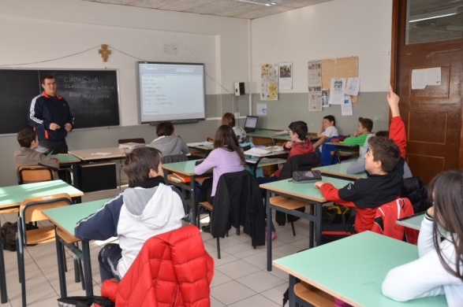

…we ask questions and …

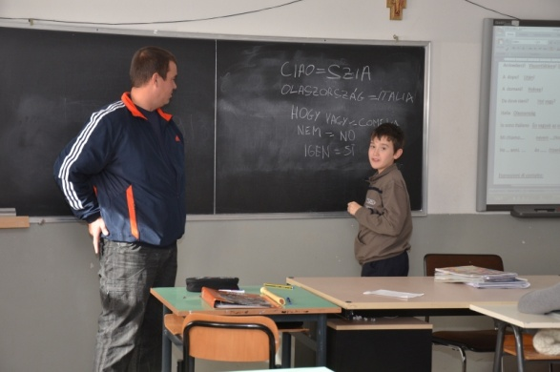

…have a try at the blackboard and …

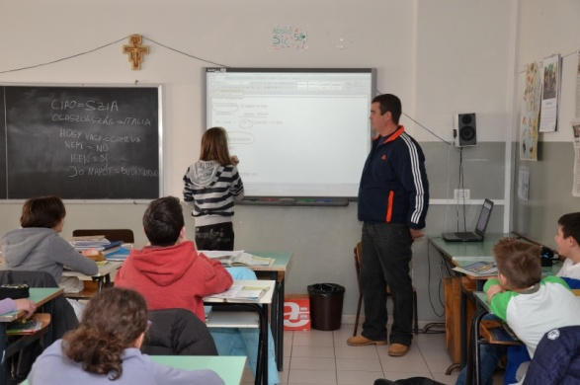

… at our Interactive White Board.



Thanks a lot Mr Csep Tunde!!!